

CA PPM v14.4  
CA PPM 15.1

Strategic Planning Documentation  
Release 5.2 – Installation Procedure

**Table of Contents**

1. Installation Instructions 3

1.1. Pre-requisites for installation 3

1.2. Pre-Installation Steps 3

1.3. Installing the Application for the First Time 4

1.4. Post-installation procedures 5

1.5. Installing Demo Data 9

1.6. Demo Data Post-Installation 10

2. Upgrade Instructions 15

3. Known Issues 15

4. Technical Summary 16

4.1. Object Description 16

4.2. Pages 17

4.3. Processes 18

# Installation Instructions

## Pre-requisites for installation

1. At this time, the Strategic Planning accelerator is prepared to work with CA PPM On Demand and On Premises, running both on Oracle and SQL Server databases.
2. You have sleep.exe installed. Possible installation locations: C:/apps/clients, C:/apps/userapps, C:/apps/gnuwin32/bin
3. You have XOGinstalled for the proper version (v14.4)
4. Increase XOG memory size to 1.5GB
   1. Go to your XOG Bin Folder (i.e. c:\apps\clients\xog\bin)
   2. Edit XOG.BAT in Notepad++
   3. Search for the string “**-Xmx**” using <CTRL+F>
   4. Replace the number that follows –Xmx with 1536m – like this: **-Xmx1536m**
   5. Save and Close Notepad++
5. You have in you CA PPM installation a **user** called “**xog**” that has a password “**gox**” with **all access rights** to xog stuff in.
6. **If you want to use the Strategic Maps, Strategic Heat Maps, Hierarchies, Word Trees and Sankey Diagrams you will need to load the “Hierarchical Views” package**. Follow the instructions from the file “Hierarchical Views – Installation.docx” to install Hierarchical Views if necessary.

## Installing the Application for the First Time

1. Download the Package ZIP file from the CA Wiki page.
2. Unzip the package file into your c:\temp folder.
3. Open Windows Explorer and Navigate to C:\Temp\StratPlanning_v5_2
4. Right-Click and Edit file “StratPlanning_v5_2Install.bat”
5. Locate the line where the XOG_HOME variable is set and replace the path to reflect your XOG installation path
6. Locate the line where the SERVERNAME variable is set and replace the value with your server name or IP address
7. Locate the line where the PORTNUMBER variable is set and replace it with the appropriate value (normally, it’s 80)
8. Locate the line where the USERNAME variable is set and replace it with the username you will use (default is the ‘xog’ user)
9. Locate the line where the PASSWORD variable is set and replace it with the password for that user (default is ‘gox’)
10. Locate the line where the JAVA_HOME variable is set and replace it with the correct JAVA_HOME path
11. Locate the line where the SLEEP_HOME variable is set and replace it with the correct path for the SLEEP.EXE utility
12. If you are loading into a new Dataset which might have changes in the Business Alignment page for Projects (or Alignment & Risk for Ideas) it may be a good idea to comment out the lines referring to the “Stock Views”.
    1. Replace “Call” with “rem Call” for all lines corresponding to the files starting in “145-”
13. If you are NOT using Hierarchical Views r3
    1. Replace “Call” with “rem Call” for the line corresponding to file “300-SeedData_customObjectInstance_001_1_1.xml”
    2. Replace “Call” with “rem Call” for the line corresponding to file “300-SeedData_customObjectInstance_002_1_1.xml”
14. Save the file
15. If there are any additional instructions inside the file – please follow those instructions
16. Run the file by double-clicking it.
17. Navigate to C:\Temp\StratPlanning_v5_2\output
18. Check all the output files for errors.
19. You shouldn’t see any errors. If you do, try to verify the reason and correct it. It’s ok to run it again after you correct something. If you don’t find the problem, drop me a note and I’ll try to help you out.
20. Security warnings for Pages and Portlets are normal – they will be corrected when the Groups are loaded. Security warnings for Groups are also normal – they will be corrected when Seed Data is loaded.
21. If you find an empty file it may be because XOG Timed Out or had an Out-of-Memory issue before writing the log file. Normally, the file will have been executed correctly after a while. You may run only that file again, just to be sure, or you can check CA PPM and see if the changes were correctly applied.
    1. Files **143-StockObjectCustomAttributes_inv_*.xml** are the ones that will take longer (around 10 minutes each) and may get a time out (output file empty, size = 0) open the investment objects (Project, Idea, Service, Application, etc) to verify the strat_corp_alignment, strat_bu_alignment, strat_dept_alignment, strat_align_score, strat_sup_goals and strat_fund_source are available.

## Post-installation procedures

1. Login to Clarity with “Admin”
2. Go to the Admin tool
3. Click on Processes
4. Filter all processes starting with “Strat”.
5. Activate all listed processes by clicking on them, navigating to “validation” and clicking on “Validate All and Activate”.
6. If you wish to use the new Dimensional Alignment attributes in Portfolios:
   1. Open the “Portfolio Investment” object
   2. Click “Attribute Registry”
   3. Add the Alignment attributes to the Registry. The Default dimensions are Business Unit, Department and Corporate. The attributes are Business Unit Alignment, Department Alignment and Corporate Alignment – respectively
   4. Add the Overall Alignment Score attribute as well
   5. Save and Return
7. There are known issues with Links and Actions. You will need to perform these steps:
   1. Open the “Strategic Indicator” object
   2. Click Linking
   3. Look for the “General SubPage Strategic Indicator Indicator Target List link” link:
      * Copy the Action ID in the “Action” column (it should look like **SubPage.5070099.actionLink**) and paste it in the Action ID column on Row “A” of the table below
      * Click on the Link Name and Copy the Link ID (it should look like **strat_kpi.strat_kpi_target.5039212.link**) and paste it in the Link ID column on Row “A” of the table below
   4. Look for the “General SubPage Strategic Indicator Indicator Measurement List link” link:
      * Copy the Action ID in the “Action” column (it should look like **SubPage.5070100.actionLink**) and paste it in the Action ID column on Row “B” of the table below
      * Click on the Link Name and Copy the Link ID (it should look like **strat_kpi.strat_kpi_measure.5039212.link**) and paste it in the Link ID column on Row “B” of the table below

|  |  |  |  |
| --- | --- | --- | --- |
| Ref | Link Name | Action ID | Link ID |
| A | General SubPage Strategic Indicator Indicator Target List link |  |  |
| B | General SubPage Strategic Indicator Indicator Measurement List link |  |  |

* 1. Open the “Strategic Item” object
  2. Click Linking
  3. Look for the “Strategic Item Top Down Planning by Stage Link” link:
     + Copy the Action ID in the “Action” column (it should look like **SubPage.5070110.actionLink**) and paste it in the Action ID column on Row “C” of the table below
     + Click on the Link Name and Copy the Link ID (it should look like **strategic_item.strat_td_planning**) and paste it in the Link ID column on Row “C” of the table below

|  |  |  |  |
| --- | --- | --- | --- |
| Ref | Link Name | Action ID | Link ID |
| C | Strategic Item Top Down Planning by Stage Link |  |  |

* 1. Open the C:\Temp\StratPlanning_v5_2\260-Queries.xml file in Notepad++ and run a “Replace Command” with the following data, then Save.

|  |  |
| --- | --- |
| From | To |
| SubPage.5152284.actionLink | <the Action ID for the “A” line on the Table above, such as **SubPage.5070099.actionLink**> |
| SubPage.5152285.actionLink | <the Action ID for the “B” line on the Table above, such as **SubPage.5070100.actionLink**> |
| SubPage.5152292.actionLink | <the Action ID for the “C” line on the Table above, such as **SubPage.5070110.actionLink**> |

* 1. Open the C:\Temp\StratPlanning_v5_2\230-Views.xml file in Notepad++ and do a “Search and Replace” using <CTRL+H> with the following data, then Save.

|  |  |
| --- | --- |
| From | To |
| strat_kpi.strat_kpi_target.5094571.link | <the Link ID for the “A” line on the Table above, such as **strat_kpi.strat_kpi_target.5039212.link** > |
| strat_kpi.strat_kpi_measure.5094571.link | <the Link ID for the “B” line on the Table above, such as **strat_kpi.strat_kpi_measure.5039212.link** > |

1. Navigate to C:\Temp\StratPlanning_v5_2
2. Follow these steps if you require the use of Strategic Maps and Hierarchical Views (HierViews Package must be installed)
   1. Login to CA PPM
   2. Navigate to Home, Setup, HTML Files List
   3. Click on the wsdl_wrapper.js file
   4. Click on the “Choose File” and select C:\Temp\StratPlanning_v5_2\wsdl_wrapper.js
   5. The file will be uploaded to the HTML File object Instance
   6. Right-click the file “Open” icon and choose “Copy link address”
   7. Paste the results in the “A” row on the Table below
   8. Copy the part of the URL containing the “fileId” and paste on the “C” row on the Table below. It should look like the “B” row, but probably with a different ID Number.
   9. Copy the part of the URL containing the “versionId” and paste on the “E” row on the Table below. It should look like the “D” row, but probably with a different ID Number.
   10. Copy the part of the URL containing the “odf_pk” and paste on the “G” row on the Table below. It should look like the “F” row, but probably with a different ID Number.

|  |  |
| --- | --- |
| A | http://SERVERNAME/niku/app?action=union.viewODFFile&fileId=5102205&versionId=5102206&odf_pk=5001000&objectType=hiev_html_file&filedownload=filedownload&RhXm0r7tSeUqEr=true |
| B | fileId=5102205 |
| C |  |
| D | versionId=5102206 |
| E |  |
| F | odf_pk=5001000 |
| G |  |

* 1. In CA PPM, click Save and Return.
  2. Click on the hierView.html file
  3. Right-click the file “Open” icon and choose “Copy link address”
  4. Paste the results in the “H” row on the Table below
  5. Copy the part of the URL containing the “fileId” and paste on the “C” row on the Table below. It should look like the “B” row, but probably with a different ID Number.
  6. Copy the part of the URL containing the “versionId” and paste on the “E” row on the Table below. It should look like the “D” row, but probably with a different ID Number.
  7. Copy the part of the URL containing the “odf_pk” and paste on the “G” row on the Table below. It should look like the “F” row, but probably with a different ID Number.

|  |  |
| --- | --- |
| A | http://SERVERNAME/niku/app?action=union.viewODFFile&fileId=5101215&versionId=5101216&odf_pk=5000000&objectType=hiev_html_file&filedownload=filedownload&RhXm0r7tSeUqEr=true |
| B | fileId=5101215 |
| C |  |
| D | versionId=5101216 |
| E |  |
| F | odf_pk=5000000 |
| G |  |

* 1. Right-click and Edit file “265-Portlets_html.xml”
  2. Run a “Search and Replace” operation Searching for the text in “B” and Replacing all occurrences with the text in “C” from **BOTH** tables above
  3. Run a “Search and Replace” operation Searching for the text in “D” and Replacing all occurrences with the text in “E” from **BOTH** tables above
  4. Run a “Search and Replace” operation Searching for the text in “F” and Replacing all occurrences with the text in “G” from **BOTH** tables above
  5. Save the File

1. Right-Click the file “StratPlanning_v5_2PostInstall.bat” and select “Edit” from the Drop Down Menu
2. Locate the line where the XOG_HOME variable is set and replace the path to reflect your XOG installation path
3. Locate the line where the SERVERNAME variable is set and replace the value with your server name or IP address
4. Locate the line where the PORTNUMBER variable is set and replace it with the appropriate value (normally, it’s 80)
5. Locate the line where the USERNAME variable is set and replace it with the username you will use (default is the ‘xog’ user)
6. Locate the line where the PASSWORD variable is set and replace it with the password for that user (default is ‘gox’)
7. Locate the line where the JAVA_HOME variable is set and replace it with the correct JAVA_HOME path
8. Save this file
9. If there are any additional instructions inside the file – please follow those instructions
10. Run the file by double-clicking it.
11. Navigate to C:\Temp\StratPlanning_v5_2\output
12. Check all the output files for errors.
13. You shouldn’t see any errors. If you do, try to verify the reason and correct it. It’s ok to run it again after you correct something. If you don’t find the problem, drop me a note and I’ll try to help you out.
14. If you find an empty file it may be because XOG Timed Out before writing the log file. Normally, the file will have been executed correctly after a while. You may run only that file again, just to be sure, or you can check CA PPM and see if the changes were correctly applied.
15. Manually change the Idea and the Project Views to add the following (if necessary):
    1. Add “Strategic Alignment” section to Alignment & Risk (on Ideas) and Business alignment (on Projects and Programs)
    2. Add Overall Strategic Score, Corporate Alignment, Business Unit Alignment and Department Alignment to the Left Column
    3. Add Strategic Funding Source and Supported Goals to the Right Column.
    4. On the View’s “Fields” add the Image Icons to the Alignment Attributes.
16. You need to go to the Administration Menu and configure two new Time-Slices:
    1. Request Name must be “Planned Cost for Top-Down Plan”; field Investment Cost Plan; monthly rollover; monthly period; 30 periods; Start Jan 1st 2015
    2. Request Name must be “Planned Benefit for Top-Down Plan”; field Investment Benefit Plan; monthly rollover; monthly period; 30 periods; Start Jan 1st 2015
17. This version of Strategic Planning brings a new UI Theme “CA PPM Strat UI” based on the “Teal and Grey” standard theme.
    1. Set CA PPM Strat UI as the Default Theme and the UI Theme for your users’ Partitions

OR

* 1. Open the Theme of your choice and add the following lines to the end:

/* Strategic Planning Package */

#stratparentdiv

{

position: relative;

width: 1000px;

height: 660px;

}

.stratItem {

position: absolute;

width: 30px;

height: 30px;

background-color: #444;

border-radius: 60px;

cursor: pointer;

cursor: hand;

}

.stratItemBlack {

background-color: #000;

}

.stratItemRed {

background-color: red;

}

.stratItemYellow {

background-color: yellow;

}

.stratItemGreen {

background-color: green;

}

.stratItemBlue {

background-color: blue;

}

.stratItemWhite {

background-color: #fff;

}

.stratItem > div {

color: #fff;

font-size: 10px;

text-align: center;

vertical-align: middle;

line-height: 30px;

}

.stratItemYellow > div {

color: #000!important;

font-size: 10px;

text-align: center;

vertical-align: middle;

line-height: 30px;

}

1. You may need to correct the Filter Portlet mapping for the Strategic Review Tab:
   1. Go to Portlet Pages
   2. Find “Strategic Review”
   3. Click on the “Tabs” tab
   4. Click “Strategic Review”
   5. Click “Page Filters” tab
   6. Click on the Mapping Icon
   7. Make sure **Strategic Plan** is mapped to **param_plan_id** for **both portlets**
   8. Make sure **Item Level** is mapped to **param_level** for the **Heat Map portlet**
   9. Click Save and Return
   10. Click Save and Return
2. If you are not using the Hierarchical Views (Strategic Heat Map and Hierarchy portlets), perform these additional steps:
   1. Go to Portlet Pages
   2. Find “Strategic Item Default Layout”
   3. Click “Tabs”
   4. On the “Strategic Map” tab de-select the “Active” column
   5. Repeat the same process for the “Hierarchy” tab of the “Strategic Indicator Default Layout” Portlet Page

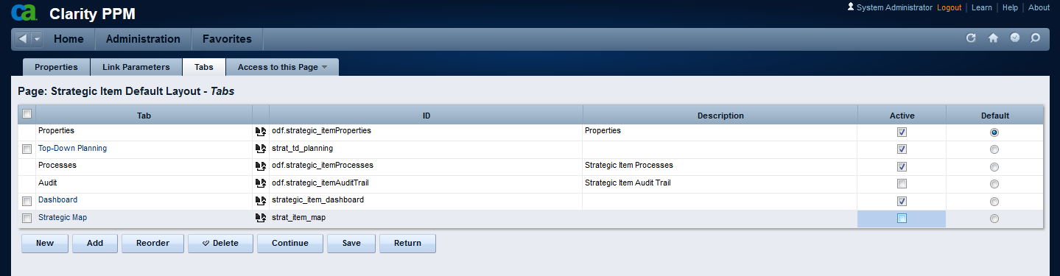

* 1. Remove The Hierarchy Icon from:
     + Object Strategic Item, List View
     + Object Strategic Indicator, List View
     + Portlet: Strategic Hierarchy with Indicators
     + Portlet: Strategic Indicator Hierarchy

## Installing Demo Data Part 1

1. After installing the application, if demo data is necessary, follow these steps
2. Right-Click the file “StratAlignment_v5_2Install_Demo_Part1.bat” and select “Edit” from the Drop Down Menu
3. Locate the line where the XOG_HOME variable is set and replace the path to reflect your XOG installation path
4. Locate the line where the SERVERNAME variable is set and replace the value with your server name or IP address
5. Locate the line where the PORTNUMBER variable is set and replace it with the appropriate value (normally, it’s 80)
6. Locate the line where the USERNAME variable is set and replace it with the username you will use (default is the ‘xog’ user)
7. Locate the line where the PASSWORD variable is set and replace it with the password for that user (default is ‘gox’)
8. Locate the line where the JAVA_HOME variable is set and replace it with the correct JAVA_HOME path
9. Save this file
10. Run “StratPlanning_v5_2Install_Demo_Part1.bat”
11. Navigate to C:\Temp\StratPlanning_v5_2\output
12. Check all the output files for errors.
13. You shouldn’t see any errors. If you do, try to verify the reason and correct it. It’s ok to run it again after you correct something. If you don’t find the problem, drop me a note and I’ll try to help you out.
14. Login to CA PPM as Admin
15. Navigate to Home, Organizer, Processes, Available
16. Start a new instance of process “Strategic Item Demo Data Fix”
17. Wait for the process to finish
18. Navigate to <http://servername/niku/nu#action:security.caches>
19. Click Flush All
20. Click the Groups TAB
21. Click Flush All
22. Clear your Browser Cache
23. Continue the installation of Demo Data Part II

Note: you may (or may not) find a series of warnings like these, not to worry about them:

<Severity>WARNING</Severity>

<Description>com.niku.union.odf.exception.ODFValidationException: ODF-0015: Value must be unique.</Description>

## Installing Demo Data Part 2

1. Right-Click the file “StratAlignment_v5_2Install_Demo_Part2.bat” and select “Edit” from the Drop Down Menu
2. Locate the line where the XOG_HOME variable is set and replace the path to reflect your XOG installation path
3. Locate the line where the SERVERNAME variable is set and replace the value with your server name or IP address
4. Locate the line where the PORTNUMBER variable is set and replace it with the appropriate value (normally, it’s 80)
5. Locate the line where the USERNAME variable is set and replace it with the username you will use (default is the ‘xog’ user)
6. Locate the line where the PASSWORD variable is set and replace it with the password for that user (default is ‘gox’)
7. Locate the line where the JAVA_HOME variable is set and replace it with the correct JAVA_HOME path
8. If you are not using hierarchical views and strategic maps, replace “call” with “rem call” for file “400-DemoData_customObjectInstance_170_1_1.xml”
9. Save this file
10. Run “StratPlanning_v5_2Install_Demo_Part2.bat”
11. Navigate to C:\Temp\StratPlanning_v5_2\output
12. Check all the output files for errors.
13. You shouldn’t see any errors. If you do, try to verify the reason and correct it. It’s ok to run it again after you correct something. If you don’t find the problem, drop me a note and I’ll try to help you out.

## Demo Data Post-Installation

To finish installing demo-data, follow these steps:

1. As an Admin, login to the application. Navigate to “Evaluation Cycles” under “Strategic Alignment”

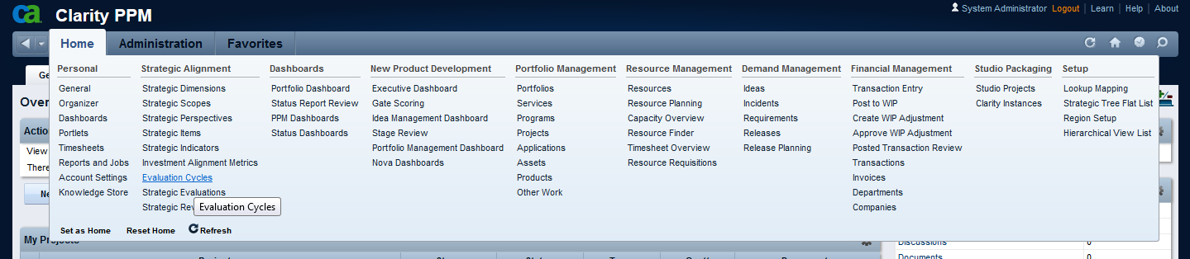

1. You’ll see three different cycles in “Close” state. Change them all to “Wait” and save.
2. Start the processes by selecting each of the cycles on the List View and using the Action “Manually Start Process” from the Actions Menu.   
   It is better to do it one Cycle at a time.

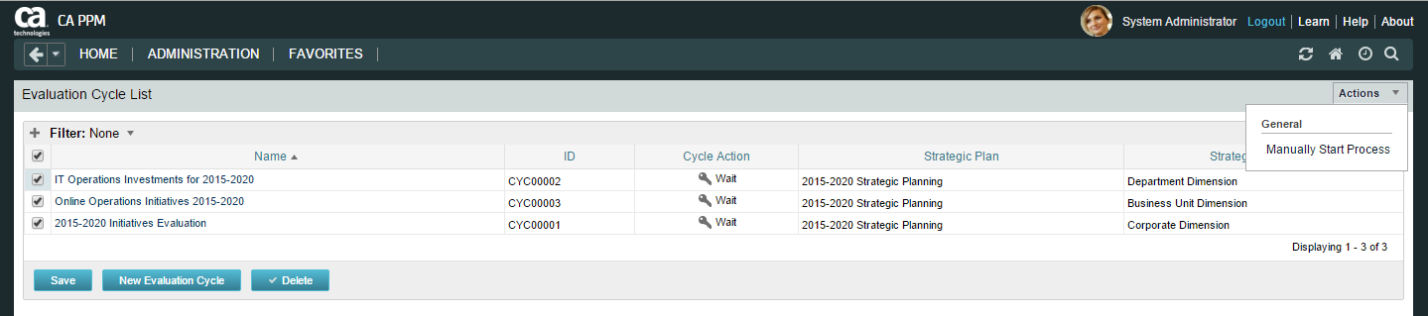

Change the Cycle action to “Start” and Save, better to do it one at a time, not all three together. 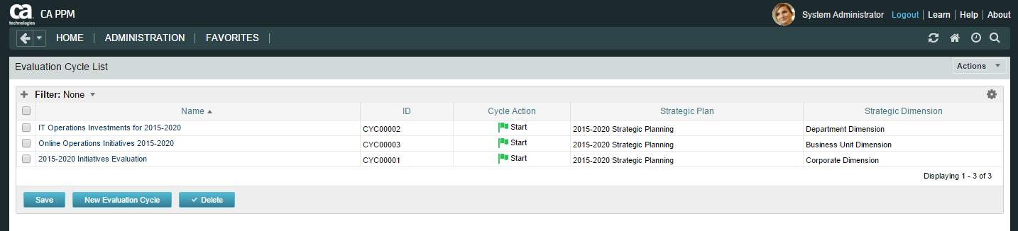

1. Now there should be a process on each one of those Cycles, and they should be at the “Distribute Evaluation” Step. If the process is in error for any reason, just restart the process – or cancel and start another instance. This is known to happen for an unknown reason.

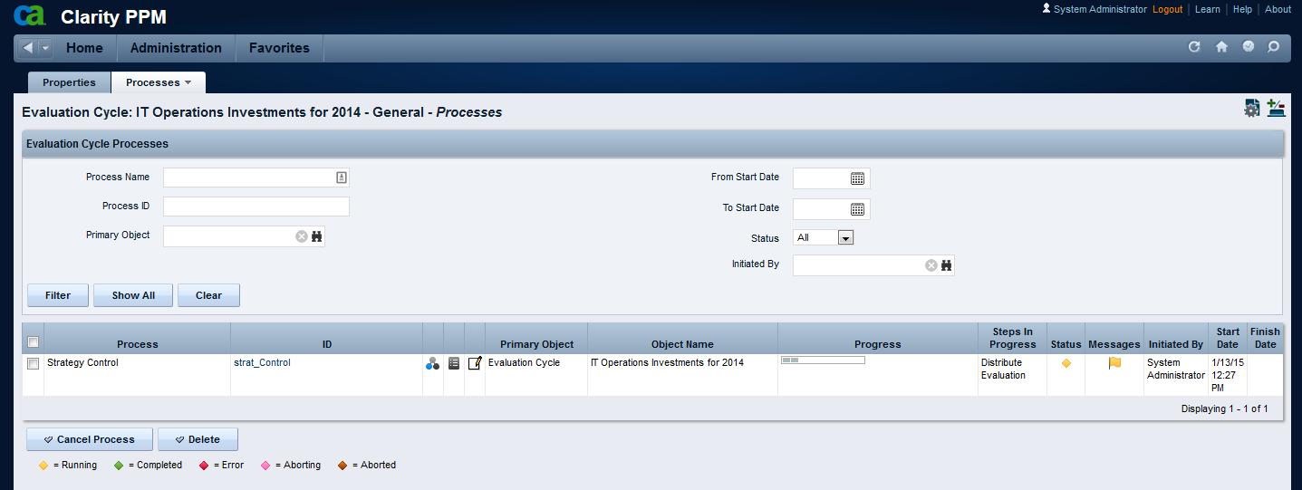

1. Change the Cycle Action to “Close” for all three Cycles and Save. If you need to restart the processes, you can just select the corresponding cycles on the List View and use the new Action “Manually Start Process” from the Actions Menu.

It is better to do it one at a time, not all three together.

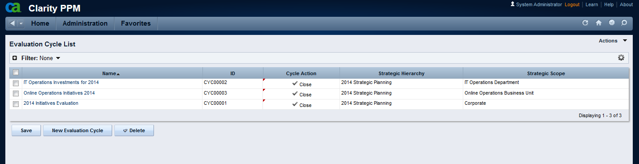

1. All three processes should now finish successfully.

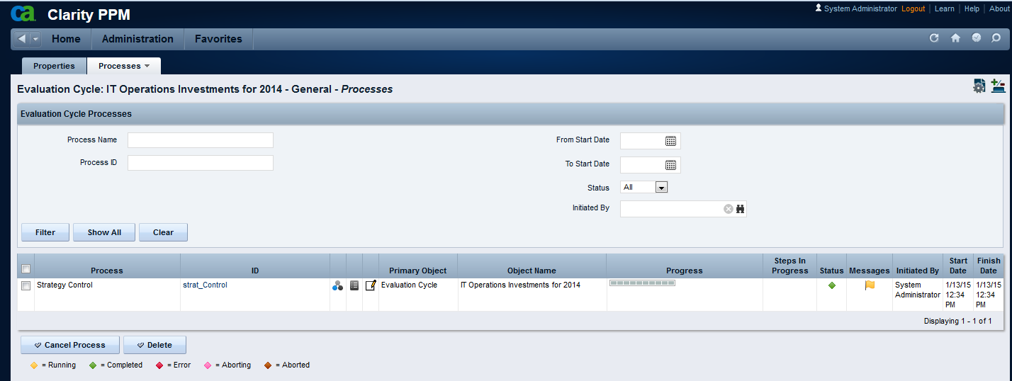

1. Navigate to the Strategic Indicators List
2. Select one of the Indicators (it doesn’t matter which one)
3. Using the Actions Menu, execute the “Recalculate Indicator and Item Status Now” action. This process will recalculate Indicators and Item Status and update the Measurements, Indicators and Items “Last Measurement Status” information (new feature).
4. If you are using Strategic Maps Follow these steps (Hierarchical Views are a Pre-req):
   1. Navigate to Home, Setup, HTML File
   2. Click on file “**2016-2021 Corporate Plan.png**”
   3. Click the “Choose File” button
   4. Select C:\Temp\StratPlanning_v5_2\2016-2021 Corporate Plan.png and click “Open”
   5. Right-Click the “Open” icon and choose “Copy link address”
   6. Paste the results in the corresponding column of row “A” in the Table below (overwrite the existing example)
   7. Click Save and Return
   8. Repeat steps b-g for files **2016 IT Plan.png** and **2016 Operations Plan.png**
   9. Copy the part of the URL containing the “fileId” and paste on the “C” row on the Table below. It should look like the “B” row, but probably with a different ID Number.
   10. Copy the part of the URL containing the “versionId” and paste on the “E” row on the Table below. It should look like the “D” row, but probably with a different ID Number.
   11. Copy the part of the URL containing the “odf_pk” and paste on the “G” row on the Table below. It should look like the “F” row, but probably with a different ID Number.

|  |  |  |  |
| --- | --- | --- | --- |
|  | 2016-2021 Corporate Plan | 2016 IT Plan | 2016 Operations Plan |
| A | http://SERVERNAME/niku/app?action=union.viewODFFile&fileId=5103202&versionId=5103203&odf_pk=5002000&objectType=hiev_html_file&filedownload=filedownload&RhXm0r7tSeUqEr=true | http://SERVERNAME/niku/app?action=union.viewODFFile&fileId=5103207&versionId=5103208&odf_pk=5002001&objectType=hiev_html_file&filedownload=filedownload&RhXm0r7tSeUqEr=true | http://SERVERNAME/niku/app?action=union.viewODFFile&fileId=5103212&versionId=5103213&odf_pk=5002002&objectType=hiev_html_file&filedownload=filedownload&RhXm0r7tSeUqEr=true |
| B | fileId=5103202 | fileId=5103207 | fileId=5103212 |
| C |  |  |  |
| D | versionId=5103203 | versionId=5103208 | versionId=5103213 |
| E |  |  |  |
| F | odf_pk=5002000 | odf_pk=5002001 | odf_pk=5002002 |
| G |  |  |  |

* 1. Go to Strategic Planning, Strategic Items
  2. Find **2016-2021 Corporate Plan** and open it
  3. Click Setup
  4. On the “Map URL” attribute, Replace the file ID, version ID and odf_pk with the ones from rows “C”, “E” and “G” above.
  5. Repeat these final steps for **2016 IT Plan** and **2016 Operations Plan**.

1. Demo Data installation is now complete.

# Upgrade Instructions

**Pre-requisite for upgrade**: you must have a working version of Strategic Alignment using one of these versions:

StratPlanning_v5

StratPlanning_v5_1

**Pre-Upgrade**

1. Login as Administrator
2. Delete all instances of all processes with names starting with “Strategic”
3. Change the Process Definition status for all processes with names starting with “Strategic” to “Draft” (do NOT delete the process)
4. Download the Strategic Planning ZIP file from the CA Wiki page.
5. Unzip the package file into your c:\temp folder.
6. Navigate to the package folder (i.e. C:\Temp\StratPlanning_v5_2)
7. Follow all the Installation Steps from chapter 1 – “Installation Instructions”
8. After following all instructions (Installation AND Post-Installation) follow the Post-Upgrade steps.
9. Clear your server cache

**Post-Upgrade**

1. Clear your browser cache before continuing these steps
2. Login to Clarity with “Admin”
3. Go to Home, Custom Items, Strategic Tree Flat List
4. Delete ALL records from this table
5. Go to Strategic Items
6. Filter all Strategic Plans (Level 1)
7. For each of the existing plans, Repeat:
   1. Click on the Plan
   2. Click Processes, Available
   3. Select process “Strategic Item - Rebuild Tree by Plan” and click Start

# Known Issues

If you get an error “501 – Not Implemented” when navigating to Dashboards or Hierarchical views, clear your **browser** **and** **server** caches and try again.

If that doesn’t solve the issue you may have missed a step on the installation and we may be required to fix a few links/actions manually. Send me an [email](mailto:alexandre.assis@ca.com) and I’ll get back to you as soon as possible.

We are having issues moving demo data since the release of v15.1

To fix this our workaround is to run a process to fix data referring to parametrized lookups.

These queries (Oracle format) are used to generate the demo data correction statements that are used in the GEL Script action of the “Strategic Item Demo Data Fix” process. To use:

1. Run the query
2. Copy the resulting rows and paste in the “strat_item_demo_data_fix.xml” file

select '<sql:update escapeText="false" var="vUpdate">UPDATE ODF_CA_STRATEGIC_ITEM SET PARENTITEM = (select si.id from odf_ca_strategic_item si where si.code = ''' || sp.code || ''') WHERE CODE = ''' || si.code || '''</sql:update>'

from odf_ca_strategic_item si inner join odf_ca_strategic_item sp on sp.id = si.parentitem

select '<sql:update escapeText="false" var="vUpdate">UPDATE ODF_CA_STRATEGIC_ITEM SET PLAN_RELATED = (select si.id from odf_ca_strategic_item si where si.code = ''' || pr.code || ''') WHERE CODE = ''' || si.code || '''</sql:update>'

from odf_ca_strategic_item si inner join odf_ca_strategic_item pr on pr.id = si.plan_related

select '<sql:update escapeText="false" var="vUpdate">UPDATE ODF_CA_STRATEGIC_ITEM SET RELATED_PLAN_PARENT = (select si.id from odf_ca_strategic_item si where si.code = ''' || srpp.code || ''') WHERE CODE = ''' || si.code || '''</sql:update>'

from odf_ca_strategic_item si inner join odf_ca_strategic_item srpp on srpp.id = si.related_plan_parent

# Technical Summary

## Object Description

|  |  |  |  |  |
| --- | --- | --- | --- | --- |
| **Object** | **ID** | **Master – Subobject** | **Description** | **Additional information** |
| Strategic Dimension | strat_dim | Master Object | Dimensions are types of Strategic Maps and are related to Alignment Attributes in the Investment Object.  e.g. The “Department” dimension will be used to calculate the “Department Alignment Score” | Three Dimensions are delivered as “Seed Data”:   * Department; * Business Unit; * Corporate   Additional dimensions can be easily created |
| BSC Perspective | strat_bsc_persp | Master Object | BSC Perspectives are aligned to the Balanced Scorecard tool.  e.g. the “Customer” perspective. | Four Perspectives are delivered as “Seed Data”:   * Financial; * Customer; * Internal Processes; * Learning and Growth |
| Strategic Indicator | strat_kpi | Master Object | Indicators are used to set targets and capture measurements on Key Indicators related to your Strategic Plan.  Indicators can also have their own hierarchy and cascade status and measurements from child Indicators to parent Indicators | Indicators are delivered as “Demo Data” |
| Indicator Target | strat_kpi_target | Subobject to Strategic Indicator | Targets are used to establish your goals for a specific period.  e.g. We set a Target of “95” for “Customer Satisfaction Index” Indicator at the end of 2011, “97” at the end of 2012, “99” at the end of “2013” | Targets are delivered as “Demo Data”. Demo targets are set by Year. |
| Indicator Measurement | strat_kpi_measure | Subobject to Strategic Indicator | Measurements are used to assess how we’re comparing to our targets  e.g. We have measured “Customer Satisfaction Index” on Q1 2011 as “90” and Q2 2011 as “92” | Measurements are delivered as “Demo Data”. Demo measures are set by Year, Quarter or Month, depending on the nature of the Indicator. |
| Item Status Scale | strat_item_scale | Subobject to Strategic Indicator | The Item Scale is used to normalize different scales to allow more flexibility. By default the scale is initialized with a given range for each value, but those ranges can be personalized by Indicator.  e.g. From 95% to 103% = On Target; From 103% to 9999% = Exceeded Target | Item Scales are delivered as “Demo Data”. |
| Indicator Issue | strat_issue | Subobject to Strategic Indicator | The Indicator Issue is used to report issues that may have happened and may have impacted Indicator Measurements and Results.  Indicator Issue Score will roll up from Child Indicators to their Parents and to related Items. | At this time there is no demo data. |
| Strategic Item | strategic_item | Master Object | Strategic Items are the “heart” of the system. Items are created and can be related to each other in a parent-child relation building a “Strategic Hierarchy”. Some facts about Strategic Items:   * Items may be related to a Perspective; * Items are classified in Levels; * Items may have a Parent Item; * Items may be related to an Item in another Strategic Plan (e.g. Local Plan related to Corporate Plan; Medium-Term Plan related to Long-Term Plan) * Items may be related to Indicators (that monitor their execution) * Items may be related to Alignment Metrics (that help evaluate Investments against those items) * Items may Generate Portfolios. For that you need to setup Portfolio Defaults as well as implement Top Down Planning features. |  |
| Strategy Risk | strat_risk | Subobject to Strategic Items | Strategy Risks are registered in our Strategic Items as possible occurences.  Strategic Risk Score rolls up from Items to their Parents. | At this time there is no demo data. |
| Investment Alignment Metric | strat_align_metric | Master Object | Alignment Metrics are used to assess Investments (Ideas, Projects, Programs, etc) against the Strategic Items in your Strategic Plan.  e.g. “$ Cost Reduction” | Alignment Metrics are delivered as “Demo Data”. |
| Alignment Scale | strat_metric_scale | Subobject to Investment Alignment Metric | The Metric Scale is used to normalize different Metrics in a way they can all be compared and used in a formula.  e.g. $ Cost Reduction of 500,000 is “Above Average”, giving an alignment score of “60” | Alignment scales are part of the Alignment Metrics “Demo Data”. |
| Evaluation Cycles | strat_eval_cycle | Master Object | Evaluation Cycles are used to Evaluate initiatives against your Objectives by using the Alignment Metrics associated with those Objectives. | Three evaluation cycles, one for each Dimension, are delivered as “Demo Data”. |
| Strategic Evaluations | strat_evaluation | Master Object | Strategic Evaluations are created automatically by Workflow during the execution of a cycle. They contain a “Question” about an “Investment” that should be answered by the Investment’s Manager according to the Investment Business Case. They are subject to instance-based security – only the Investment Manager can Edit these records (as well as the Administrator) | Strategic Evaluations for the three Evaluation Cycles are delivered as “Demo Data” |
| Strategic Tree Flat | strat_tree_flat | Master Object | This object is generated automatically via Workflow and is just used as an auxiliary table for building Portlets. Users should NOT have access to this object in the UI. | Strategic Tree Flat items are delivered as part of “Demo Data” referring to three different Strategic Plans |

## Pages

|  |  |  |  |
| --- | --- | --- | --- |
| **Page** | **ID** | **Custom TABs** | **Description** |
| [BSC Perspective Default Layout](http://claritylatam50/niku/nu#action:npt.getPage&pageId=odf.strat_bsc_perspFrame&id=5009062&obsType=Page&principal_type=SYSTEM&principal_id=0) | odf.strat_bsc_perspFrame | Dashboard | Portlets showing Strategic Items Hierarchy and Projects Hierarchy related to that BSC Perspective |
| [Evaluation Cycle Default Layout](http://claritylatam50/niku/nu#action:npt.getPage&pageId=odf.strat_eval_cycleFrame&id=5009056&obsType=Page&principal_type=SYSTEM&principal_id=0) | odf.strat_eval_cycleFrame | n/a |  |
| [Investment Alignment Metric Default Layout](http://claritylatam50/niku/nu#action:npt.getPage&pageId=odf.strat_align_metricFrame&id=5009038&obsType=Page&principal_type=SYSTEM&principal_id=0) | odf.strat_align_metricFrame | n/a |  |
| [Strategic Dimension Default Layout](http://claritylatam50/niku/nu#action:npt.getPage&pageId=odf.strat_dimFrame&id=5009044&obsType=Page&principal_type=SYSTEM&principal_id=0) | odf.strat_dimFrame | n/a |  |
| [Strategic Evaluation Default Layout](http://claritylatam50/niku/nu#action:npt.getPage&pageId=odf.strat_evaluationFrame&id=5009050&obsType=Page&principal_type=SYSTEM&principal_id=0) | odf.strat_evaluationFrame | n/a |  |
| [Strategic Item Default Layout](http://claritylatam50/niku/nu#action:npt.getPage&pageId=odf.strategic_itemFrame&id=5009020&obsType=Page&principal_type=SYSTEM&principal_id=0) | odf.strategic_itemFrame | Top-Down Planning  Portfolio  Risks  Setup  Strategic Map  Dashboard  Risk Analysis | Properties page pertaining to Top-Down Planning  Properties page pertaining to Portfolio attributes  Properties page pertaining to Strategy Risks list  Properties page pertaining to Item settings  Graphical Hierarchical Views  Strategic Items Hierarchy and Projects Hierarchy  Risk Analysis Dashboard |
| [Strategic Indicator Default Layout](http://claritylatam50/niku/nu#action:npt.getPage&pageId=odf.strat_kpiFrame&id=5009026&obsType=Page&principal_type=SYSTEM&principal_id=0) | odf.strat_kpiFrame | Targets  Measurements  Issues  Setup  Status Scale  Indicator Hierarchy  Dashboard | Properties page pertaining to Targets List  Properties page pertaining to Measurements List  Properties page pertaining to Issues List  Properties page pertaining to Indicator Settings  Properties page pertaining to Status Scale List  Graphical Hierarchical Views  Strategic Items Hierarchy and Projects Hierarchy |
| [Strategic Review](http://claritylatam50/niku/nu#action:npt.getPage&pageId=strat_ReviewFRAME&id=5009067&obsType=Page&principal_type=SYSTEM&principal_id=0) | strat_ReviewFRAME | Strategic Review  Strategic Plan Review  Top-Down Planning  Strategic Projects  Strategy Risks  Indicator Hierarchy  Indicator Details  Evaluation Cycle Results | New Graphical Portlets depicting the Strategic Plans  Hierarchy of Strategic Items with their Indicators  Hierarchy of Strategic Items with their Top-Down info  Hierarchy of Strategic Items with their supporting Projects  Risk Analysis at Plan Level  Hierarchy of Indicators with their Target and Measurement information  Targets and Measurements information for a Specific Indicator  Investment Alignment calculation from Evaluation Cycles |
| [Strategic Tree Flat Default Layout](http://claritylatam50/niku/nu#action:npt.getPage&pageId=odf.strat_tree_flatFrame&id=5009014&obsType=Page&principal_type=SYSTEM&principal_id=0) | odf.strat_tree_flatFrame | n/a |  |

## Processes

|  |  |
| --- | --- |
| **Process** | **Description** |
| Strategic Alignment Metric Initialize | Every time you create a new Investment Alignment Metric this process creates a blank set of “Alignment Scales” From Null (0) to Extraordinary (100) |
| Strategic Allocation Percentage | This process is used to Initialize the Allocation Percentage used in Top-Down Planning with the same value as the Weight % calculated for each Item. Also, Initializes “Allocations” and “Top-Down Received” attributes with Zero value for Benefits, Funds & FTEs. |
| Strategic Fund Allocation Initialization | Copy Top-Down Planning values to Allocated values for Lower Level Items  Resets Allocated Values for Parent Items to zero. |
| Strategic Indicator Calculation | Every time you change Indicator Targets, Indicator Measurements, Indicator Settings or Status Settings, Item Settings, or the Indicator Item Status Scale you should run this process manually to update their “Indicator Target x Measurement”, “Indicator Rollup from Children”, “Indicator % Status” and “Indicator Status” attributes and the Strategic Item’s corresponding attributes. The process is available as an Action both from the Strategic Item and the Strategic Indicator Properties and List views. |
| Strategic Indicator Issue Score | Recalculates the Issue score every time there is a significant change on the Indicator Issue list |
| Strategic Item – Build Tree Flat | Every time you change a Strategic Item this process will create records in the Strategic Tree Flat table with the Item’s parents and children in all levels up and down. |
| Strategic Item – Rebuild Tree By Plan | Use this to rebuild the Strategic Tree Flat table for a specific Plan in case of need (Example: if you XOG in new Strategic Items while the “Build” Process is inactive). |
| Strategic Item Lock Snapshot | When a Snapshot is created we lock it down so it doesn’t get any further changes. |
| Strategic Item Risk Score | Recalculates the Risk score every time there is a significant change on the Item Risks list |
| Strategic Item Status Initialize | Every time you create a new Indicator this process creates a default set of “Item Scales” From 0 (Undefined) to 6 (Exceeded Target) and you may adjust the Percentage ranges corresponding to each one. |
| Strategic Item Weight Calculation | If you change weights use this process to recalculate the weight percent for all items in the Strategic Plan |
| Strategic Plan Activate | Used to Activate a new Draft Plan |
| Strategic Plan Copy | Used to Copy a Plan to a new Draft Plan |
| Strategic Plan Create | Every time you create a new plan this process will be triggered. It is a maintenance process that fills the “Strategic Plan” attribute for the item with itself, for technical reasons. |
| Strategic Plan Snapshot | Used to Copy an Active Plan as a Snapshot for historical purposes. |
| Strategic Portfolio Creation | You should execute this process after finishing your Top-Down Planning cycle to generate the corresponding portfolios automatically. You don’t need to do it for all levels, just for those you want to manage using the Portfolio Plans, Targets and Waterlines. Lower Level Items get automatically included in parent items; Investments are selected based on the “Strategic Funding Source” attribute. |
| Strategic Rollup Allocated and Committed Funding | This process is used to sum the Allocated values and the Committed values all the way from the lower-level items to their parents. |
| Strategic Top-Down Planning Calculation | This process will distribute funds from the associated Strategic Item -> Downwards using the % Allocation defined. The values will go both to the Top-Down *Received* attributes and to the Top-Down attributes. The first ones hold this value in a read-only attribute. The second ones can be adjusted to allow for some “strategic reserve” of funds/FTEs. |
| Strategy Control | Every time you create a Strategic Cycle this process will help Distribute the Evaluation Questions; once they are answered it will Calculate Weights, Calculate the Alignment Scores and Update Investments. |